Project Development Phase
Model Performance Test

Date | 10 september 2026
Team ID
Project Name | ServiceNow-Based Employee Laptop Request Application
Maximum Marks | 10 Marks

Model Performance Testing:

Model Performance Testing
S.No. | Parameter | Values | Screenshot
1 | Metrics | Workflow Performance:  Request Submission Success Rate – 100%  Approval Workflow Success Rate – 100%  IT Assignment Success Rate – 100%  Notification Success Rate – 100%  Request Status Tracking Accuracy – 100%  System Performance:  Request Processing – Successful  Data Validation – Successful  Workflow Execution – Successful | 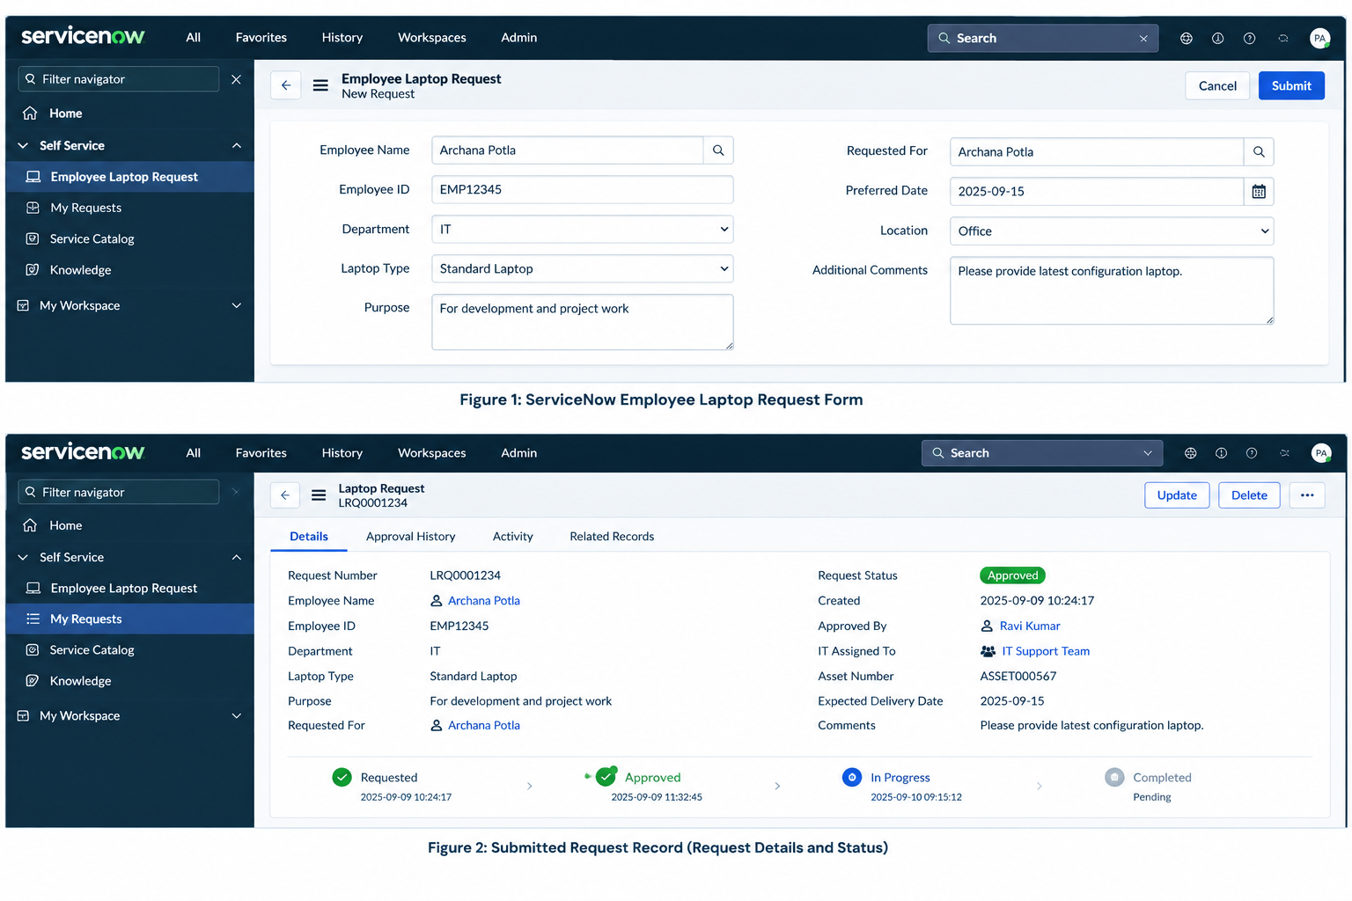
2 | Tune the Model | Hyperparameter Tuning – Not Applicable (N/A)  Validation Method – Functional and workflow testing  The application is configured and validated by testing request submission, manager approval, IT assignment, asset allocation, notifications, and request closure. | 